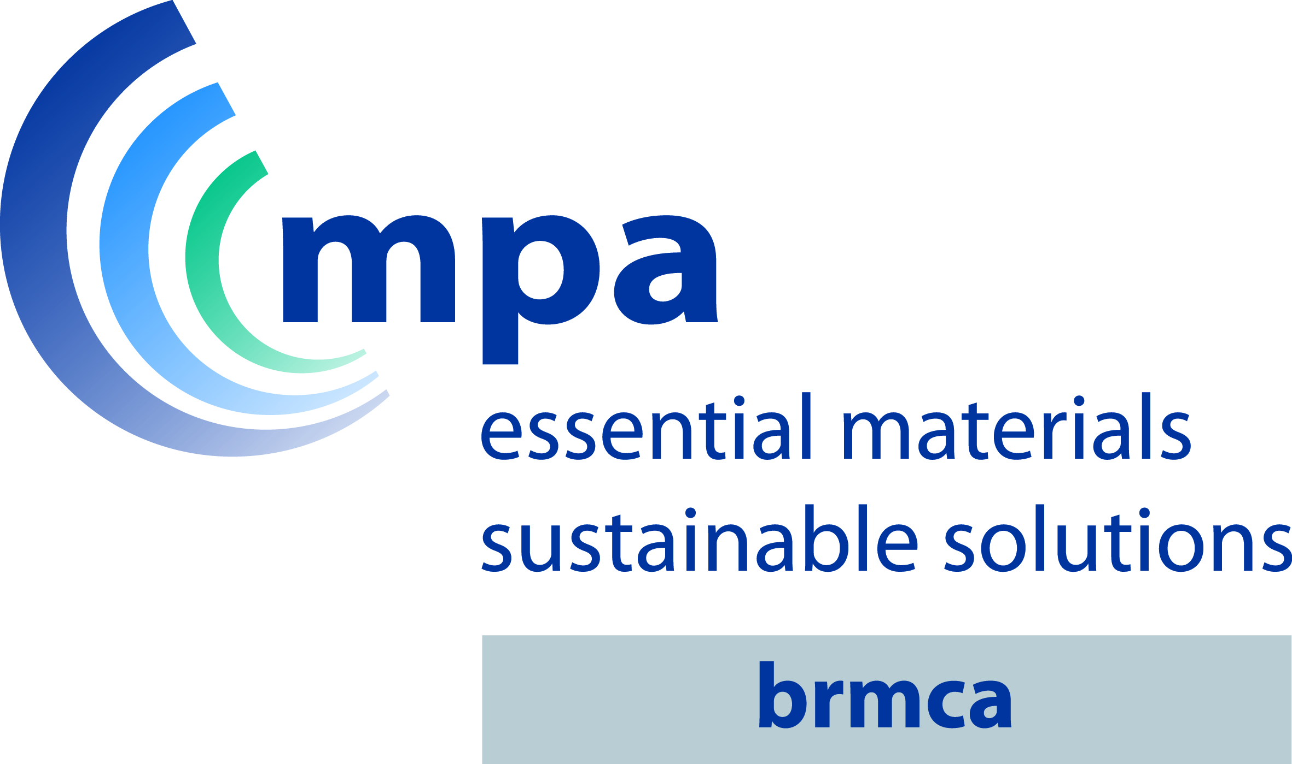

British Ready-Mixed Concrete Association
‘Excellence in Customer Service Award’
Entry form for ‘2016 Award’

The completed entry form including contractor verification together with at least two high quality photographs* to be sent to Chris A Clear, by 31 July 2016

Please do not hesitate to contact Chris A Clear if you require any additional information or clarification, but well before the due date.

e: chris.clear@mineralproducts.org
m: 07976 546941

*A practical test for digital photographs is to enlarge them so that they completely fill a minimum 14" computer or laptop screen without looking pixelated.
Entry Details:
Company name proposed for award:
(Full address, Tel No and contact name)

Supplying plant (s):
(Full address)

Contractor:
(Full address & Tel No.)

Project name and site location:
(Project name and full site address)

Contractor contact name & contact details:
(Full address and Tel No.)

Date of supply/supply term:

Concrete Mix details:

Summary of service provided
Please summarise the service provided, difficulties overcome and reason for consideration re: ‘Excellence in Customer Service Award’.
It is important to include the customer verification of the ‘Excellence in Customer Service’
Please also provide pictures* and detailed technical commentary if appropriate. *A practical test for digital photographs is to enlarge them so that they completely fill a minimum 14" computer or laptop screen without looking pixelated.

Declaration:
Person completing the entry form:

Contact address:
(Include email and Tel No.)

Signed:……………………………..Dated:……………………………….

Name of Contractor Representative Verifying Content if not named above:

Name:………………………………..…

Signed:………………………………….Dated:…………………………………….

